**Year 4 – Autumn Curriculum Letter**

Welcome back to St. Mary’s for the Autumn Term. I hope you had an enjoyable and restful summer break. This newsletter will inform you of the exciting things that your child will be learning about over the next term.

**General reminders**

Please ensure that your child reads every day and that this is noted in your child’s home-school diary. Children’s reading should be noted in the home-school diary at least 4 times a week. If there are any important notes, especially regarding a change in pick-up arrangements, please ensure that these notes are clearly written in the home-school diary.

Please ensure your child has the correct uniform every day and that all of your child’s belongings are clearly name-labelled.

Our PE days this term are Tuesday and Wednesday afternoons. Children may also come to school in their PE kit on these days and if they have an after (or before) school club.

Spellings homework sheets now replace the weekly spellings test, and these will be given out each Friday, to be returned by the following Friday. Children should practice their times tables daily using TT-Rockstars, for no more than 10 minutes. We will be completing paper times tables drills each day in class and will have a weekly times tables test on a Friday.

Mr Bentley’s release time and Senior Leadership Team duties will be covered by Mrs Dyer and Mrs Cuifo.

**Curriculum**

**RE (Religious Education)**

**Creation and covenant:** ‘The heavens are telling the glory of God’ (Ps 19:1). In this branch, pupils will encounter the God who creates and calls a people. They will explore revelation of the Christian belief that all that is comes from God, the Creation accounts in Genesis, and scientific explanations of the process of Creation. They will explore the call of God and his covenantal relationship with his people first through Abraham and Moses, then through the narrative of the Old Testament.

|  |  |  |  |
| --- | --- | --- | --- |
| **Year 4 Autumn 1 Creation and Covenant** | | | |
| **Branch 1: Creation & Covenant** | | | |
| **Lens** | **Knowledge Lens Content** | **Ways of Knowing** | **Expected Outcomes** |
| **Hear** | The story of Abraham, focusing on the these key texts:   * The call of Abram (Gen 12:1-5) * The Abrahamic covenant (Gen 15:1-6) * Abraham and Sarah (Gen 18:1-15) * Abraham and Isaac (Gen 22:1-18)   (Optional) The story of Joseph, focusing on the following key texts: Gen: 37:2-35, 41:1-42, 44:1-17, 33-34, 45:1-5, 16-20 | **Understand** | Show some understanding of the historical context of Abraham (and Joseph) and the cultural and religious context out of which he was called. |
| By the end of this unit of study, pupils will know some facts about:  -The historical, cultural, and religious context out of which Abraham was called.  -The importance of understanding historical context to appreciate the literal sense of biblical stories. | Retell the story of Abraham, ensuring it is accurate in sequence and detail and shows an understanding of the term ‘covenant’. |
| Show an understanding of the story of Abraham and Isaac (Genesis 22:1-18), recognising the importance of historical context in explaining the meaning of this story then and now. |
| **Believe** | By the end of this unit of study, students will know that the Church teaches that:  -God’s covenant with Abraham is the foundation of the faith of the people of the Old and New Testaments: Judaism and Christianity  -Faith is believing in God, trusting what God reveals, and following God’s loving purpose to live a good life.  -Through living out virtues of faith, hope, and love (sometimes referred to as charity), Christians are drawn into a closer relationship with the Holy Trinity.  -Abraham is a model of how to pray. |
| Recognise that God’s covenant with Abraham is the foundation of the faith of the people of the Old and New Testaments: Judaism and Christianity. |
| Show some understanding of how the decisions of Abraham (and Joseph) were informed by their faith, hope, and love in God. |
| Make links between prayers that show trust in God and the virtues of faith, hope, and love. |
| **Celebrate** | By the end of this unit of study, pupils will know:  Age-appropriate extracts from prayers of faith in God from the Catholic tradition. (For example, Ps 40:1, the St Therese prayer, ‘May today there be peace within’, St John Henry Newman’s ‘Mission of my Life’, Bl Charles de Foucauld’s ‘Prayer of Abandonment’.) | **Discern** | By the end of this unit of study, pupils will be able to talk and think critically and creatively about what they have studied, for example, through: |
| Describing and explaining the virtues: faith, hope, and love making links between these virtues of and the life of a person who was an example of faith made active in love (e.g., the intervention of Cardinal Manning in the London dockworker’s strike in 1889). |
| **Live** | By the end of this unit of study, pupils will know:  -The virtues of faith, hope, and love.  -The life and work of a person who was an example of faith made active in love, e.g., the intervention of Cardinal Manning in the London dockworker’s strike |
| Explaining why they think Abraham is seen as a model of prayer. |
| **Respond** | During this unit of study, pupils will be invited to respond to their learning, for example by: |
| Considering how their own lives and the lives of their communities could be transformed by the virtues of faith, hope, and love. |
| Reflecting on how the virtues of faith, hope and love help them to be a good neighbour. |
| Reflecting on the challenges and blessings Abraham (and Joseph) experienced and how their faith played a part in how they reacted. |
| **Key vocabulary**: Covenant, Abraham, Sarah, Isaac, Joseph, forgiveness, virtue, faith, hope, love. | | | |

**Prophecy and promise:** ‘In many and various ways, God spoke to our ancestors by the prophets’ (Heb 1:1). The prophets speak of God reaching to his people, calling them back into a relationship with him. In this branch, pupils will explore the Christian understanding of the teaching of the prophets as they point to the fulfilment of God’s promise in a messiah, Jesus Christ. They will explore the expectant waiting for the Messiah through the Advent season and how this speaks to Christians today as they wait for Christ. Pupils will encounter the story of the nativity of Jesus and the mystery of the incarnation.

|  |  |  |  |
| --- | --- | --- | --- |
| **Year 4 Autumn 2 Prophecy and Promise** | | | |
| **Branch 2: Prophecy & Promise** | | | |
| **Lens** | **Knowledge Lens Content** | **Ways of Knowing** | **Expected Outcomes** |
| **Hear** | The miracle of the flour and the oil (1 Kings 17:7-14) | **Understand** | By the end of this unit of study, pupils will be able to: |
| Elijah’s encounter with God: the journey 1 Kings 19:4-8, The meeting: 1 Kings 19:9-15 | Show some understanding of the cultural and religious context of Elijah’s time and why people needed to be reminded of God’s covenant. |
| The preaching of John the Baptist (Matt 3:1-12 and Mk 1:1-8) |
| Isaiah 40:3 (contained within the gospel accounts) |
| The ancestry of Jesus (Matt 1:1-17) |
| By the end of this unit of study, pupils will know some facts about:  The importance of understanding historical context to appreciate the literal sense of biblical stories.  What is meant by ‘prophecy’. | Compare the description of John the Baptist in Mark and Matthew’s accounts and describe the beliefs about John the Baptist the gospel writers show. |
| **Believe** | By the end of this unit of study, pupils will know that the Church teaches that: | Make links with the words of Isaiah, the preaching of John the Baptist, and the season of Advent. |
| For Christians, the prophets awaken an expectation of the coming of the Messiah in people’s hearts. |
| John the Baptist is sent to prepare the way for Jesus. | Know that the feast of Christ the King marks the end of the Church’s year and describe what is celebrated. |
| In the Advent liturgies, Christians pray for the second coming of Jesus alongside preparing for Christmas. |
| Advent is a time of preparation for Jesus’ incarnation at Christmas and for the second coming as King of the Universe. | Makes links with the ancestry of Jesus and the Jesse tree. |
| **Celebrate** | By the end of this unit of study, pupils will know: | **Discern** | By the end of this unit of study, pupils will be able to talk and think critically and creatively about what they have studied, for example, through: |
| The Feast of Christ the King. |
| The Jesse tree. | Responding to a variety of artistic ways in which the Jesse tree is portrayed. Suggest reasons for the artist’s choices and give reasons for their personal preference. |
| ‘He will come again in glory’ from the Nicene Creed. |
| **Live** | By the end of this unit of study, pupils will know:  -How Christians prepare for the coming of Christ during Advent.  -How Christians use the Jesse tree during Advent, identifying its meaning and representation in art around the world, connecting to God’s plan for salvation.  -How some artists have depicted Jesus Christ as King. . |
| Talking about the type of king they think Jesus would be and give reasons for their answers. |
| Responding to a variety of artistic ways in Christ the King portrayed. Suggest reasons for the artist’s choices, give reasons for their personal preference and compare their ideas with others. |
| **Respond** | During this unit of study, pupils will be invited to respond to their learning, for example by: |
| Reflecting on how Elijah and John the Baptist’s words speak to people today. |
| Reflecting on what it means to be a good leader and talk to others about their ideas. |
| **Key vocabulary**: Advent prophet Elijah John the Baptist Jesse Tree Christ the King | | | |

**Maths**

Our areas of focus up until Christmas are Place Value, Addition, Subtraction, Multiplication, Division, Area and Perimeter. Children will develop their fluency, reasoning and problem solving skills in these areas.

Children will continue to be tested on their times tables weekly. Regular practise of these is very important and can have a significant, positive impact on the maths attainment and the Government Times Tables Test in June 2025.

|  |  |
| --- | --- |
| **Place Value**  Place Value: Recognise the place value of each digit in a 4-digit number.  Round any number to the nearest 10, 100 or 1000.  Compare: Order and compare numbers beyond 1000.  Solve number and practical problem.  Find 1000 more or less than a given number.  Identify, represent and estimate numbers using different representations.  Read Roman numerals to 100 (I to C) and know that over time, the numeral system changed to include the concept of zero and place value. | **Addition and Subtraction**  Add and subtract numbers with up to 4 digits using the formal written methods of columnar addition and subtraction where appropriate.  Estimate and use inverse operations to check answers to a calculation.  Solve two-step addition and subtraction problems in contexts, deciding which operations and methods to use and why.  Solve problems, including missing number pattern problems, using number facts, place value and more complex addition and subtraction. |
| **Multiplication and Division**  Recognise and use factor pairs and commutativity in mental calculations.  Recall multiplication and division facts for multiplication tables up to 12 x 12.  Use place value known and derived facts to multiply and divide mentally, including multiplying by 0 and 1; dividing by 1; multiplying together three numbers.  Use place value known and derived facts to multiply and divide mentally, including multiplying by 0 and 1; dividing by 1; multiplying together three numbers.  Multiplying 2 digits by 1 digit. Efficient multiplication  Multiplying 2 digits by 1 digit. Written methods.  Multiplying 2 digits and 3 digit by 1 digit using a formal written method.  Solve problems involving multiplication and adding, including using the distributive law to multiply tow digit numbers by one digit, integer scaling problems and harder correspondence problems such as n objects are connected to objects.  Divide 2 digits by 1 digit. Efficient multiplication  Divide 2 digits by 1 digit. Written methods.  Divide 2 digits and 3 digit by 1 digit using a formal written method.  Short division with remainders. | **Fractions and Area**  Find the area of rectilinear shapes by counting squares.  Measure and calculate the area of a rectilinear figure (including squares) in centimetres and metres. |

**English**

Children will continue to develop their comprehension and writing skills through the study of our class texts.

Children will also develop a greater understanding of the Y4 vocabulary, grammar and punctuation.

Children will have the opportunity for free reading in class and they will further develop their reading skills in guided reading sessions. However, we do recommend that the children read at home with an adult daily.

|  |  |  |
| --- | --- | --- |
| **Reading**   * The Raven * The Queen’s Nose * The Girl Who Stole and Elephant. | **Writing**   * Poems which explore form A * Persuasive writing (adverts) A * First person diary entries (imaginative) A * Critical analysis of narrative poetry A * Third person adventure stories A * Newspaper reports A | **SPAG** |
| Ask questions to improve their understanding of a text.  Drawing inferences such as inferring characters’ feelings thoughts and motives rom their actions and justifying inferences with evidence.  Making predictions from what might happen from details stated and implied.  Discussing words and phrases that capture the reader’s interest and imagination.  Listening to and discussing a wide range of fiction, poetry, plays, non-fiction and reference books or textbooks  Preparing poems and play scrips to read aloud and to perform showing understanding through intonation, tone volume and actions.  Recognising some different forms of poetry for example, free verse, narrative poems.  Checking that the text makes sense to them, discussing their understanding and explaining the meaning of words in context.  Develop positive attitudes to reading and an understanding of what they have read by: listening to and discussing a wide range of fiction, poetry, plays, non-fiction and reference or textbooks.  Retrieve and record information from non-fiction. | To begin to use ideas from their own reading and modelled examples to plan their writing  To compose and rehearse sentences orally (including dialogue), progressively building a varied and rich vocabulary and an increasing range of sentence structures.  To consistently organise their writing into paragraphs around a theme to add cohesion and to aid the reader.  To increase the legibility, consistency and quality of their handwriting (e.g. by ensuring that the down strokes of letters are parallel and equidistant; that lines of writing are spaced sufficiently so that the ascenders and descenders of letters do not touch).  To make deliberate ambitions word choices to add detail.  To proofread consistently and amend their own and others writing correcting errors in grammar, punctuation and spelling and adding nouns/pronouns for cohesion.  To begin to read aloud their own writing to a group or the whole class using appropriate intonation to control the tone and volume so that meaning is clear.  To write a range of narratives and non-fiction pieces using a consistent and appropriate structure (including genre-specific layout devices)  Rehearse sentences orally (including dialogue), progressively building a varied and rich vocabulary and an increasing range of sentence structures. | Fronted adverbials (for example, Later that day, I heard the bad news.)  Noun phrases expanded by the addition of modifying adjectives, nouns and prepositional phrases (e.g. the teacher expanded to: the strict maths teacher with curly hair)  Expressing time, place and cause using conjunctions (for example, when, before, after, while, so, because) adverbs for example (then, next, soon, therefore) prepositions (for example, before, after, during, in, because of).  Heading and sun-headings to aid presentation.  Use of paragraphs to organise ideas around a theme. |

**Science**

Our topics for this term are Biology ‘Living things and their habitats’ and Chemistry ‘States of Matter’.

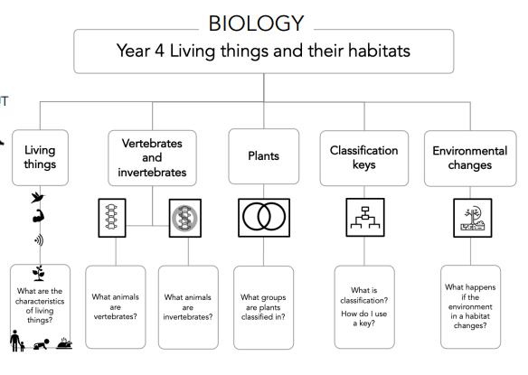

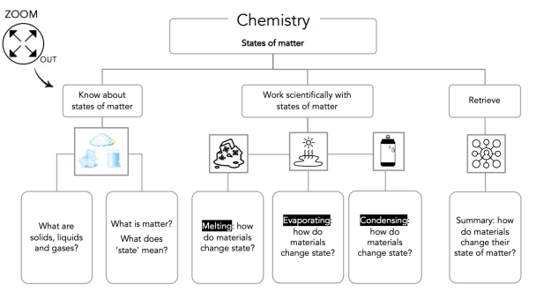

Children will continue to develop their ‘Working Scientifically’ skills by planning, designing, undertaking and evaluating their own investigations.

**Geography**

Our topics for this term are Human and Physical Geography ‘Rivers’ and Location ‘Latitude and Longitude’.

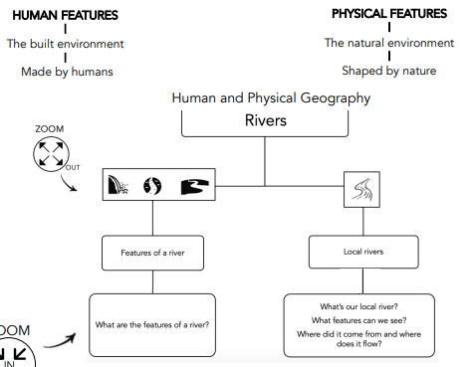

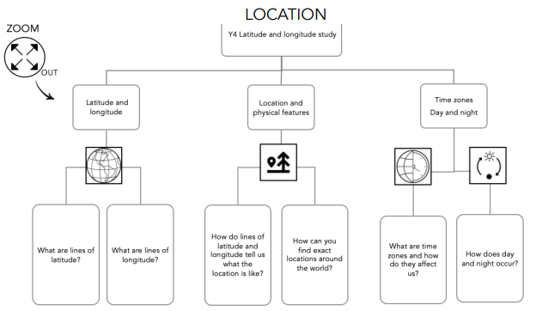

**History**

Our topic for the term is Invasion, Power and Community ‘Britain’s Settlement of Anglo Saxons and Scots’ and ’ The Viking and Anglo-Saxon struggle for the Kingdom of England to the time of Edward the Confessor’.

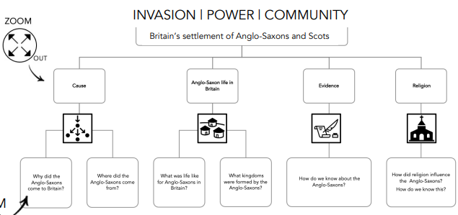

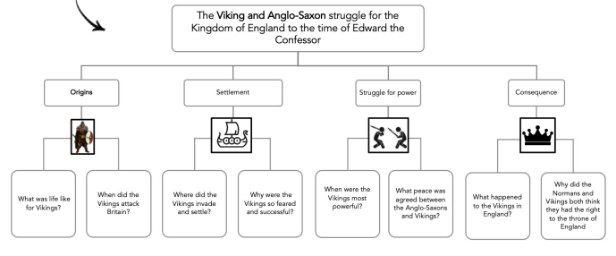

**Art**

Our topics for the term are ‘Drawing’ and ‘Painting’.

|  |
| --- |
| **Drawing** |
|  |

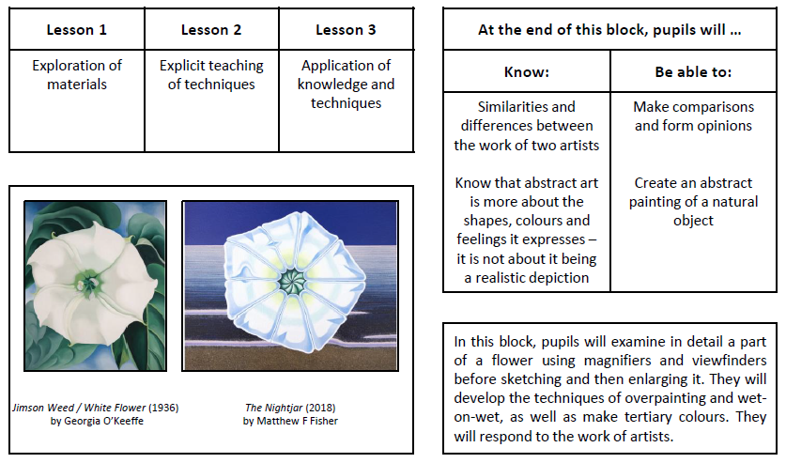

**DT Design and Technology**

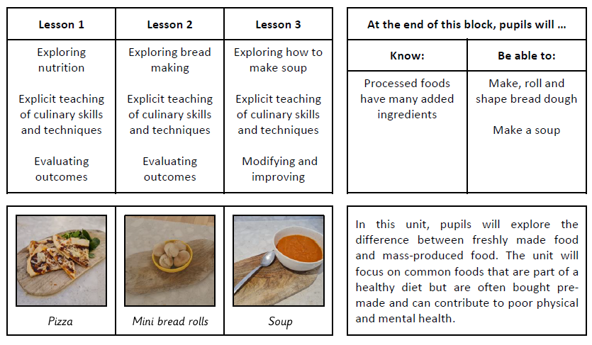

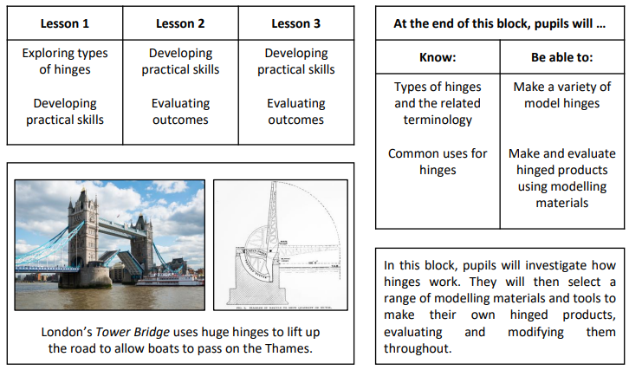

**Computing**

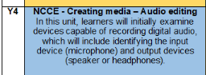 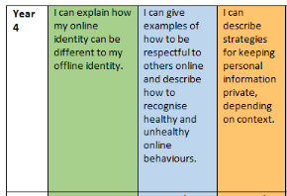

**P.H.S.E. (POSSIBLY SUBJECT TO CHANGE)**

At St Mary’s Catholic Primary School, we believe that PSHE/RSHE are intertwined subjects that goes beyond being a standalone subject and underpins everything we do. It extends through all aspects of the school to help our pupils develop the knowledge, skills and attributes they need to manage their lives, develop resilience, now and in the future and helping to develop socially aware individuals.

The teaching of the PSHE/RSHE curriculum is rooted in the Catholic Church’s teaching of what is it to be truly human in Christ and what is means to live well in relationships with others.

At St Mary’s Catholic Primary School we follow the Ten:Ten programme which is based on A Model Catholic RSE Curriculum, produced by the Catholic Education Services, and was highlighted as a work of good practice by the Department for Education.. As well as this it provides an all-inclusive programme for all faiths. Each unit is story focused and provides faith based resources such as:

· Interactive videos

· Story based activities

· Music

· Prayers

Ten:Ten delivers the Statutory Guidance provided by the Department for Education and exceeds this by far.

We believe that a successful PSHE/RSHE curriculum is taught in partnership with parents as they are they first educators in a child’s life. Our Curriculum aims to fulfil the mission of the Church through an interconnected relationship between home, school and the Church. Ten:Ten provides an online parent portal, providing access to resources to support discussions about taught content.

Our topics this Term will be:-

|  |  |
| --- | --- |
| L1- Stand alone lesson focusing on Learning Behaviours and Rules  L2- Get up! (x2 sessions)  L3 Get up! (x2 sessions)  L4- **Mental Health Lesson**  **L5- World Mental Health Day 10/10**  L6- Online safety (Self Image and Identity)  L7- Online safety (Online Relationships) | L1- Online safety (Privacy and Security)  L2- **Anti-Bullying Week- WB 11/11**  L3- **Mental Health Lesson**  L4- **Mental Health Lesson**  L5- Stand alone PSHE lesson based on class’ needs  L6- Stand alone PSHE lesson based on class’ needs |

**PE**

Our focus for this term is on honing our skills in games and outdoor adventurous activities. PE will be taught by Mrs Dyer on Tuesday and Wednesday afternoons.

**Music and French**

Music and French will be taught by Mrs Dyer on Tuesday afternoons.

I look forward to working closely with you over the term. Should there be any questions or problems, please do not hesitate to make an appointment to see me.

With very best wishes,

Mr Bentley