St Mary’s Newsletter
Issue 5 17th November 2023
St. Mary’s Catholic Primary School, Woodbridge Road, Ipswich, IP4 4EU
http://www.stmaryscatholicprimaryipswich.com

Dear Parents and Carers,

This week has been Anti-bullying Week. The theme has been ‘Make a Noise About Bullying’. We have been thinking about the difference between ‘banter’, ‘arguments’ and ‘bullying’. We have thought about the
definition of bullying: ‘to frighten or hurt a weaker
person; to use your strength or power to make somebody
do something’. There are some ways we can make
a noise about bullying.

Warm Regards

Mrs Berry and Mrs Measham

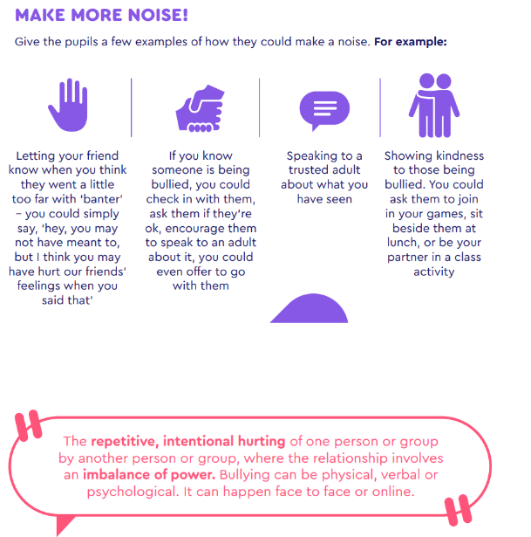
Tweet of the Week
“Every human being, of any people or religion, every human being is sacred, is precious in the eyes of God and has the right to live in peace. Let us not lose hope: let us pray and work tirelessly so that a sense of humanity may prevail over hardness of heart.”
Pope Francis (@Pontifex)

School Rules:
Be ready, Be respectful, Be safe

Week Commencing 20th November 2023
Tues 21st Nov: Year 5 Swimming
Tues 21st Nov & Wed 22nd Nov: Online Parents' Evening for Reception
Tues 21st Nov & Thurs 23rd Nov: Online Parents' Evening for Years 1-6
Mon 27th November – Remote Curriculum Evening 6-7pm
Thurs 30th Nov: Year 6 Parish Mass in Church, 9.15am
Fri 1st Dec: Key Stage 1 Advent Service 9am at school
Parents/carers welcome

CLUBS & ACTIVITIES
Mondays
Football Club (years 1, 2, 3) starts 3.30pm. Children collected at 4.30pm. This Club Is Full
Wednesdays
Christmas Ensemble for years 4, 5, 6 starts at 8.10am.
Netball Club (Girls years 5, 6) starts 3.30pm. Children collected at 4.15pm.
Football Club (Boys years 4, 5, 6) starts 3.30pm. Children collected at 4.30pm.
Thursdays
Football Club (Girls years 4, 5, 6) starts 8am.
Orchestra (years 4, 5, 6) starts 3.30pm. Children collected at 4.15pm.
Fridays
Handball & Dodgeball (KS2), starts at 12.10pm. This Club Is Full
Multisports Club (years 4, 5, 6), starts 3.30pm. Children collected at 4.30pm.
All clubs must be pre-booked. Should your child wish to join the Orchestra, please contact the School Office.

MUSIC LESSONS
Reminder of days when pre-booked and pre-paid lessons take place.
Mondays - Violin
Tuesdays – Brass
Thursdays – Woodwind
Please encourage your children to remember their instrument!

WEATHER:
Despite the weather getting colder we will hopefully still go outside for breaktime. Please ensure your child comes to school with a warm coat and gloves (plus a hat and scarf if they wish). Thank you.

JOB VACANCIES
- Effective as soon as possible, we have vacancies in school for midday supervisors to
help with our busy lunchtimes during term time.
The hours are 11.40am – 12.50pm (70mins per day); five days per week.
The current hourly rate is £10.98 (subject to pay rise in negotiation) for 38 weeks per year (plus 5 weeks paid holiday).
This is an excellent opportunity to get paid experience of working in a school.
If you would like to know more or know of someone who would like this role, please email:
admin@st-marys-ipswich.suffolk.sch.uk
- Effective from January 2024, Admin Assistant
£21,190- £21,968 pro rata, Part Time 26.5 hours per week, 38 weeks per year
Wednesday 8.30am-5.30pm, Thursday and Friday 8am to 17.30pm. Closing Date – Friday 1st December 2023, Interviews - WC 4th December 2023
All applications will be assessed upon receipt and we reserve the right to interview and appoint prior to the closing date. An early application is therefore recommended.
Administrative Assistant - Suffolk Jobs Direct Careers
- Effective from 15th January 2024, Class Teacher, Maternity Cover
MPR, Part Time, 3 days per week. Fixed term to cover maternity.
Wednesday 8.30am-5.30pm, Thursday and Friday 8am to 17.30pm. Closing Date – Monday 4th December 2023 9am, Interviews – Friday 8th December 2023
All applications will be assessed upon receipt and we reserve the right to interview and appoint prior to the closing date. An early application is therefore recommended.
Class Teacher - Maternity Cover - Suffolk Jobs Direct Careers

CAR PARK ETIQUETTE
Can we please politely remind parents/carers to drive carefully and park considerately. Safety is our top priority.

CHRISTMAS FAIR
Friends of St Mary's Christmas Fair is fast approaching. It's in the church hall on Wednesday 6th December - 1:30-3pm for the children and 3-5pm for the public. We're currently fundraising to install an amazing history wall on the school playground which will benefit all children and be a superb learning resource. As usual, to help us put on an a great fair, we have a couple of requests for help and donations.

Firstly, we're desperate for volunteers, either the day before or the day of the fair. If you can help, even for a little while, please sign up here - https://volunteersignup.org/8WJWP or email friendsofstmarysipswich@gmail.com if you can assist in any way.

Secondly, we're asking for some donations if you are in a position to help. To make life easy, here is a summary of the three things we’ll be asking for ahead of the fair:

A ‘lucky bag’ to be sold at the fair- we will send home a paper bag which your child may decorate if they like. Please fill it with little things like trinkets, sweets, rubbers, toys or pencils. No need for brand new things, just good condition - it’s the perfect opportunity to recycle party bag/Happy Meal toys.

Baked goods - we’d be incredibly grateful for any donations of baked goods. Sweet or savoury, shop bought or home-made, everything is gladly received. We will send home a paper plate with the children, and ask for baked donations to come into school on Tuesday 5th or the morning of Wednesday 6th December (fair day) for a delicious baked goods stall.

A contribution to the fair, either something for the soft drink tombola or something for a hamper. Requests for items are below, separated out by class group. We have divided up requested items between the year groups to try to provide a good mix. We will be collecting these donations between Monday 27th November and Monday 4th December so between these dates please send them in with your child, drop them into the box in front of the school office or pass them to your class rep.

Reception families, could you please bring either hot chocolate or marshmallows or mince pies or wine. These will be used for hampers.

Year 1 families, could you please bring savoury snack foods – ie crackers or crisps, bread sticks or cheese straws or a jar of pickle/chutney/jam? These will be used for hampers.

Year 3 families, could you please bring anything Christmas related - could be a Christmas pudding, florentines, Yule log, stollen, sticker book, Christmas crackers, mulled wine, Buck’s Fizz, Christmas activity pack, soft toy, card game. These will be used for hampers.

Year 5 families, could you please bring in any sweet snack foods - chocolates, sweets, biscuits, dates etc These will be used for hampers.

Years 2, 4 and 6 families, could you please bring in soft drinks - bottles, small multipacks, cartons or even a bottle of Prime - everything welcome for the soft drink and Prime tombola. Please avoid energy drinks (including Prime cans) as we won’t be able to let the children win them. Thank you so much.

We really appreciate your help with this. Please try to stick to your child’s class list, but if you can’t access any of those items easily, you can always pick from the items on the other lists. Also, if you have several children at the school, please don’t feel you have to buy for every class they’re in!

Finally, hamper raffle tickets will come home with the eldest child in each family in a week or so. We’ll have some fantastic Christmas hampers to raffle this year, not only fancy food and drink but also tempting toy hampers - no need for Santa if you win one of these, you’ll wrap Christmas up in one go!

Instructions for how to buy will be on the tickets. Please feel free to offer tickets to family and friends, and if you don’t require the tickets then please return them to the school office for resale. Extra tickets will be available via school office, class reps and at the fair.

Thanks as always for your valued support.
Friends of St Mary's PTA team

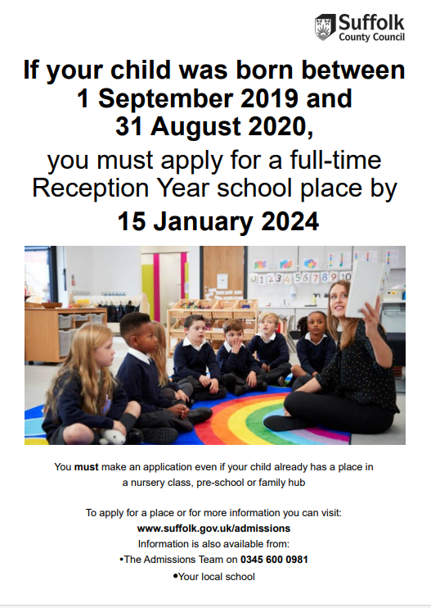

IMPORTANT: St Mary's require a completed Supplementary Information Form (SIF) which should be sent to the school before 15th January deadline please. The Supplementary Information Form (SIF) can be found on our website under Key Information - Admissions

ATTENDANCE
Please take time to read and familiarise yourself with our Trust Attendance Policy. Please be aware that the school is unable to authorise holiday requests for absence during term time.
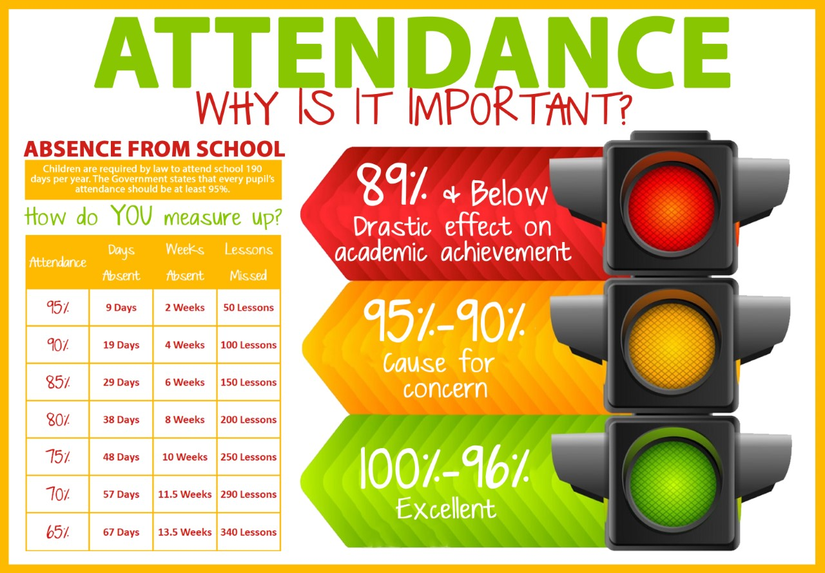
If you arrive after 8.50am, please come to the Office to sign the late book.
It is really important that you ensure your child arrives at school between 8:40 and 8:50am.
A late arrival after 8.50am means the class has already started and this is disruptive for your child and others in the class.
If your child is ill, please leave a message on the School Absence Line (01473 728372) before 8am, or send an email to: admin@st-marys-ipswich.suffolk.sch.uk
https://www.stmaryscatholicprimaryipswich.com/_site/data/files/policies/D046258157B2B78BA94749F6FB9079DE.pdf

Dear Mrs. Berry ,
Please thank all your pupils for their many gifts of tins and packets of food which were sent recently to FIND (Families in Need).
Some of these were stacked on our shelves for the food supplies we distribute daily and some were stored, ready to be packed in the 500 Christmas Hampers and gifts we deliver later in December.
The people we help are families and others who are in real need and finding it difficult to make their money cover all their bills. They are referred to us by Social Workers and many local helping charitie.
We are very grateful for your children’s concern for those who need particular help at this time.
Yours sincerely,
Heather Cade (FIND Trustee)
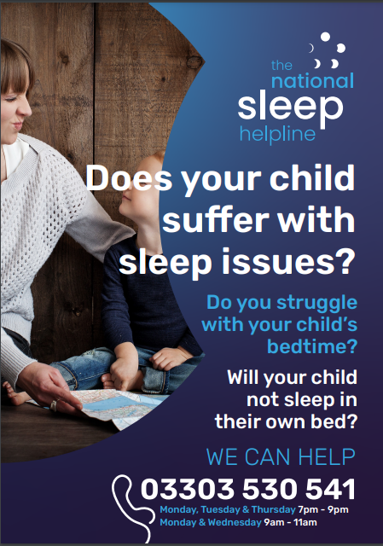

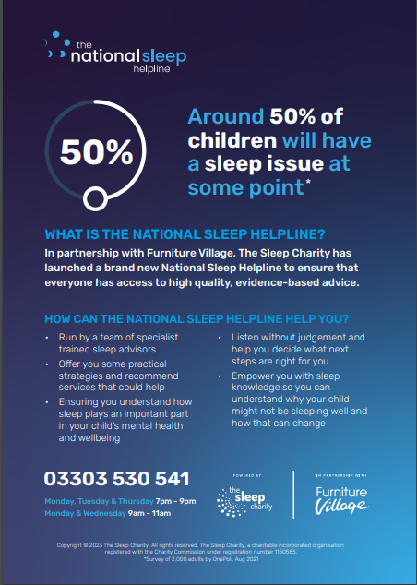

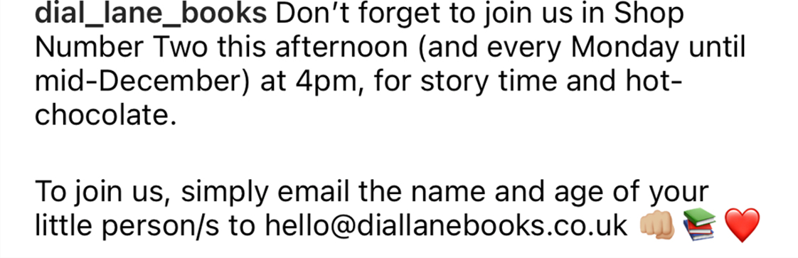

SPOTLIGHT ON YEAR 3

Year 3 have settled in really well. Please see below all the fun things they have been up to so far.
D.T.
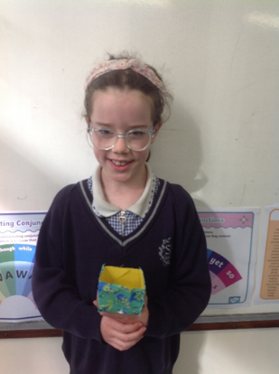
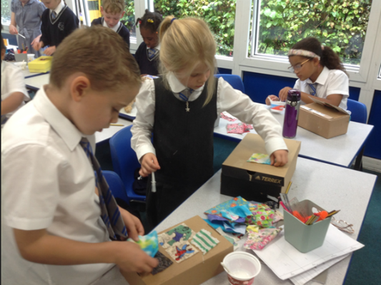
Cardboard Box Decorating: Over the last three weeks in D.T., we have been very busy creating! We started off by making a box out of card and then decorating this with different fabric. During our D.T. lessons we introduced the concept of rigidity and stiffness. We discussed how some materials can become sturdy and hold their shape. We used a variety of different solutions during our first lesson to see which solution was the best. The children then brought in some cardboard boxes from home which they decorated with lots of fabric. They turned out amazing!
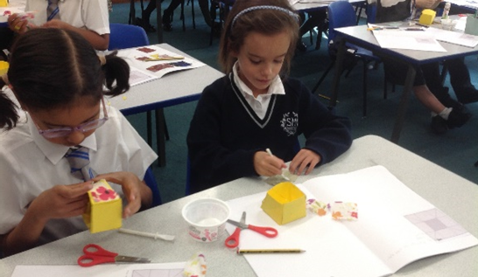
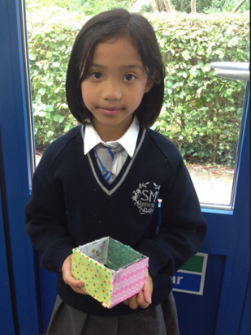

R.E.
Board games with year 5, ‘Stewards of Creation’. Year 5 created their own board games which they then brought across to year 3 to test out. Year 5 explained what they had been learning, the rules and why they created the games. It helped us to understand why it is important to care for God’s World. It was a fantastic learning experience as we engaged in strategic thinking, teamwork and, of course, lots of fun!
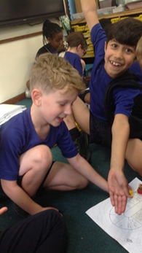
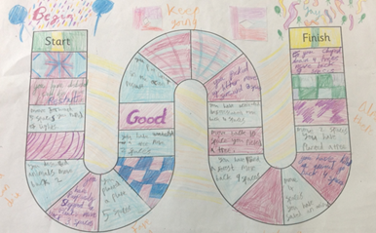
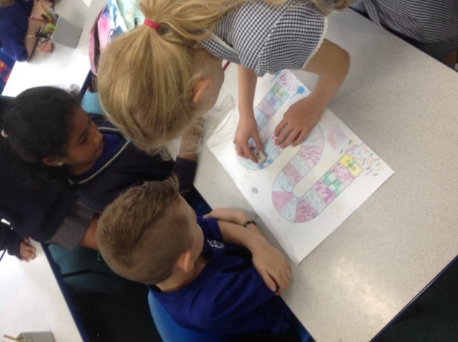

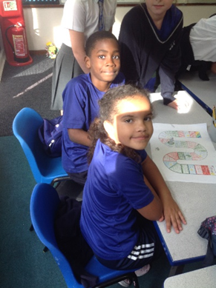

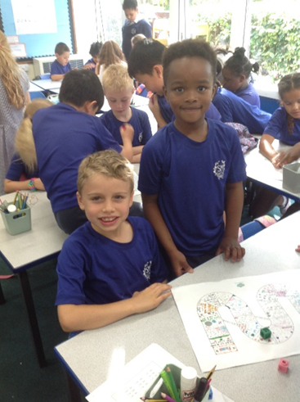

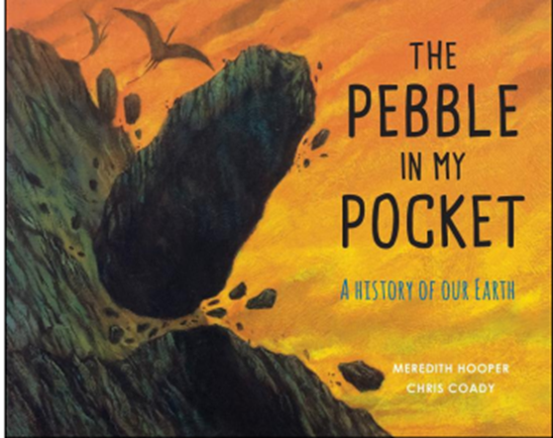
English
We have been enjoying our Guided Reading text, ‘Pebble in My Pocket.’ This book takes us on a remarkable adventure through the ages, following the incredible journey of a single pebble, from the formation of the Earth to the present day – the children have been captivated. This book has linked well with our learning in science which is about ‘Rocks’. The children have been asking insightful questions about the Earth’s history and the processes that shape our planet.

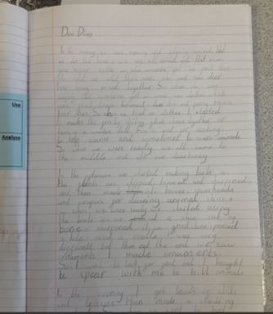
History
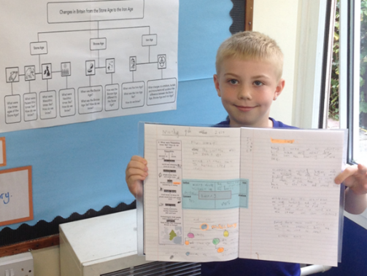
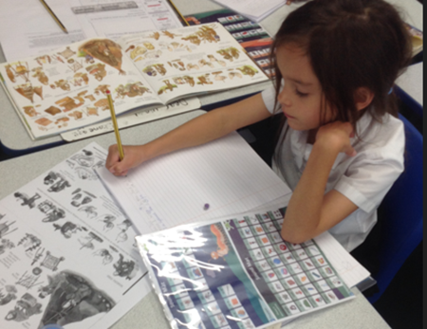
In History we are learning about the Stone Age. The children created their own diary entry and had to imagine they were living in the Stone Age era. We read the book ‘Stone Age Boy’ to help. The children worked incredibly hard and created some amazing diary entries!
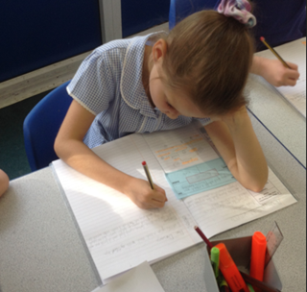
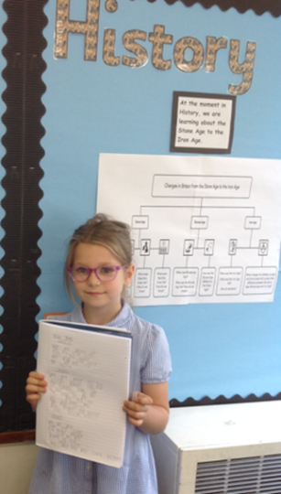
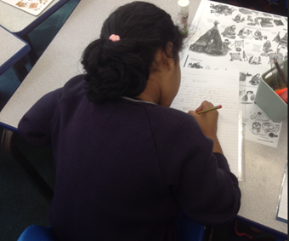

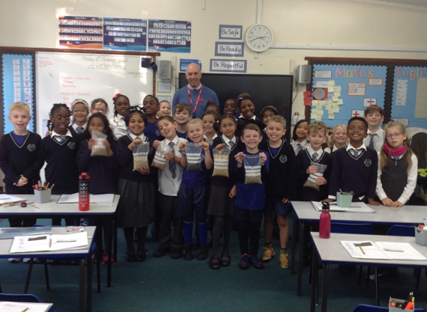
Geography
This last half term the children have been learning about fieldwork and map skills. We have been understanding and reading maps, cardinal directions and learning a lot about human and physical features. In a special and memorable lesson, we had the pleasure of hosting Mr Maskery (Miss Maskery’s Dad), who works in the farming industry and also used to be a farmer. Mr Maskery shared his life and knowledge about farming with year 3. He provided valuable insights into the day-to-day routines, this included what he used to do during school days and holidays. We understood farming is a never-ending job and farmers work all year round. We learnt about different animal feeds used and a lot about the animals, such as that sheep have four stomachs and why this is. Year 3 were absolutely captivated by the talk and immersed themselves in this hands-on experience, asking some truly fantastic questions and displaying a genuine interest in understanding the aspects of farming. The children even had the opportunity to touch and smell various animal feeds.
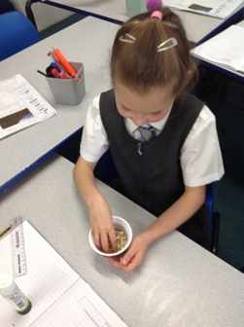
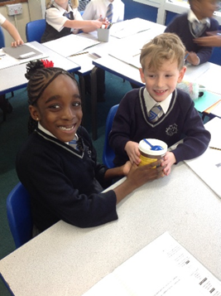
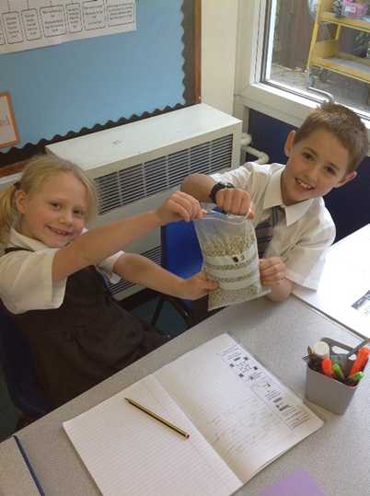
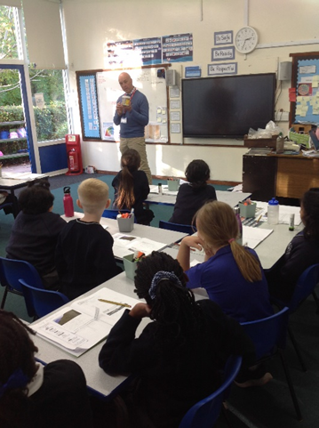

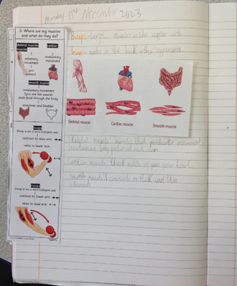
Science
Over the past couple of weeks, year 3 have delved into the fascinating world of the human body, exploring topics such as nutrition, our skeleton and muscles. A highlight was the visit from a personal trainer who graciously took the time to talk to the students about muscles. The session was not only educational but also interactive, allowing the children to engage directly with the topic. The children asked some amazing questions about muscles such as ‘how strong are your muscles’, ‘how do they help you to move,’ ‘how do muscles grow’ and ‘when you pull a muscle how long does it take to heal?’ and much more! The children participated in various exercises, including the wall sit, sit-ups, the plank and press-ups. These activities not only reinforced theoretical knowledge but also provided a first-hand understanding of which muscles are engaged during each exercise.

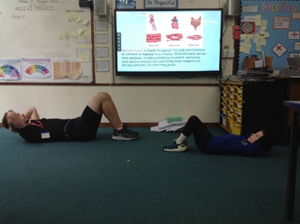
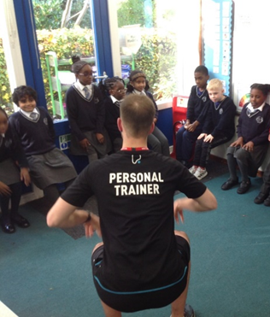
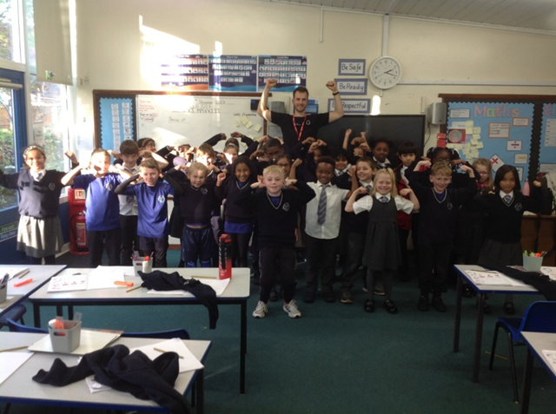
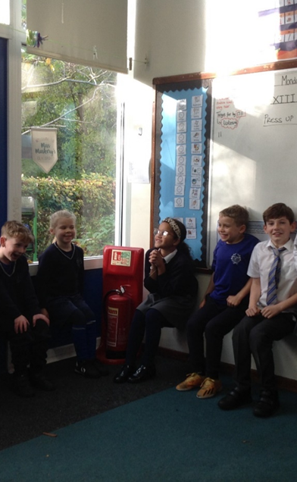
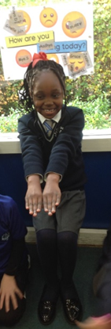

Term dates for 2023 – 2024
Autumn Term 2023
Half term: 23rd – 27th October
End of Term: Wednesday 20th December

Spring Term 2024
Thursday 4th January – Thursday 28th March
Half term: 19th – 23rd February
Staff Training day: 3rd January & 26th February

Summer Term 2024
Monday 15th April – Friday 19th July
Bank holiday: 6th May
Half term: 27th May – 31st May
Staff Training days: 12th April

