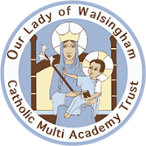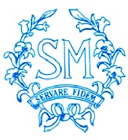

School Name: St Mary’s Catholic Primary School, Ipswich
Job Title: Teaching Assistant
Full time post – Fixed Term Contract until July 2023 – with possibility of becoming permanent
Salary £19,264 pro rata

St Mary’s Catholic Primary is a highly successful school in the centre of Ipswich. We are part of the Our Lady of Walsingham Catholic Multi Academy Trust. Required from 5th September.

We are looking to appoint an enthusiastic, caring and creative teaching assistant to join our fantastic school.

You will:

- Experience of working in a school
- Have high expectations of children’s attainment, progress and behaviour
- Be able to use your own initiative and want to help improve our children’s futures
- Enjoy being part of a team
- Have a good sense of humour
- Demonstrate a secure understanding of how children learn
- Work creatively to achieve the best outcomes for all pupils

We can offer:

- A friendly, supportive and hardworking staff and governing body
- Well behaved and motivated children
- A positive environment in our well-resourced school
- Active encouragement of personal and professional development

It is not a requirement of the role to be Catholic, but candidates should be sympathetic to the ethos of the school.

Visits to the school are welcome and encouraged, by arrangement and after school hours. Please call 01473 728372.

Further details and the application form are attached.

Application and contact details.
Completed applications should be emailed to: FAO The Heads of School, Mrs J Berry & Mrs J Measham, admin@st-marys-ipswich.suffolk.sch.uk

Closing date: 11th July 2022
Interview date: 18th July 2022

We are committed to safeguarding and promoting the welfare of children and young people and expect all staff and volunteers to share this commitment. This post is subject to an enhanced DBS check.

